Ayush Goyal
190905522 CSE D Roll 62

Operating Systems Lab 1 – Working with Regular Files

1. Write a program to print the lines of a file that contain a word given as the program argument (a simple version of grep UNIX utility).

Code:

#include<stdio.h>
#include<unistd.h>
#include<sys/stat.h>
#include<fcntl.h>
#include<stdlib.h>
#include<string.h>

int main(int argc, char const *argv[]){
int sfd,i=0,k=0;
char ch[100], chr;
if(argc!=3){
printf("\nInsufficient Arguments\n");
exit(1);
}
if((sfd=open(argv[2],O_RDONLY)) == -1){
printf("File not found.\n");
exit(2);
}
while((read(sfd, &chr, 1)) > 0){
if(chr != '\n'){
ch[i++] = chr;
} else{
k++;
ch[i] = '\0';
i=0;
if(strstr(ch,argv[1]) != NULL){
printf("Line : %d\t %s\n",k,ch);
}
}
}
exit(0);
}

We also create a txt file: sample.txt to test out output on.

Output :

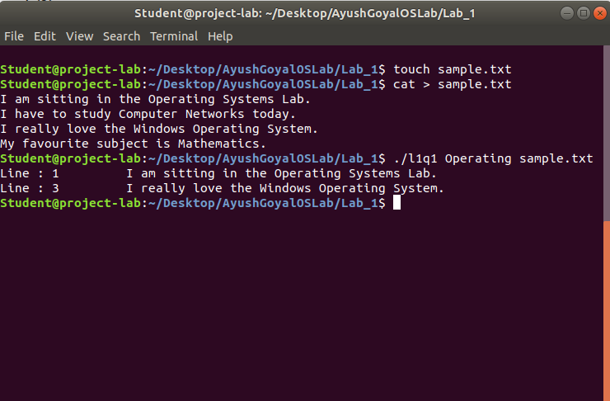

2. Write a program to list the files given as arguments, stopping every 20 lines until a key is hit. (a simple version of more UNIX utility).

Code:

#include<stdio.h>
#include<unistd.h>
#include<sys/stat.h>
#include<fcntl.h>
#include<stdlib.h>
#include<string.h>

int main(int argc, char *argv[]){
int sfd, sfd2, i=0, k=0, p=0;
char ch[100], ch2[100], chr;

if(argc != 3){
printf("\nInsufficient Arguments\n");
exit(1);
}
if((sfd = open(argv[1],O_RDONLY)) == -1){
printf("File not found!\n");
exit(2);
}
while((read(sfd, &chr, 1)) > 0){
if(chr != '\n'){
ch[i++] = chr;
} else{
k++;
p++;
ch[i] = '\0';
i=0;
printf("Line : %d\t %s\n",p,ch);
if(k == 20){
fgetc(stdin);
k=0;
}
}
}
close(sfd);

if((sfd2 = open(argv[2],O_RDONLY)) == -1){
printf("File not found!\n");
exit(2);
}
p=0;
while((read(sfd2, &chr, 1)) > 0){
if(chr != '\n'){
ch2[i++] = chr;
} else{
k++;
p++;
ch[i] = '\0';
i=0;
printf("Line : %d\t %s\n",p,ch2);
if(k == 20){
fgetc(stdin);
k=0;
}
}
}
exit(0);
}

We have created an additional file called “sample2.txt” where i have written 40 lines and i have also used the previously created “sample.txt” file. The output is shown as below:

Output :

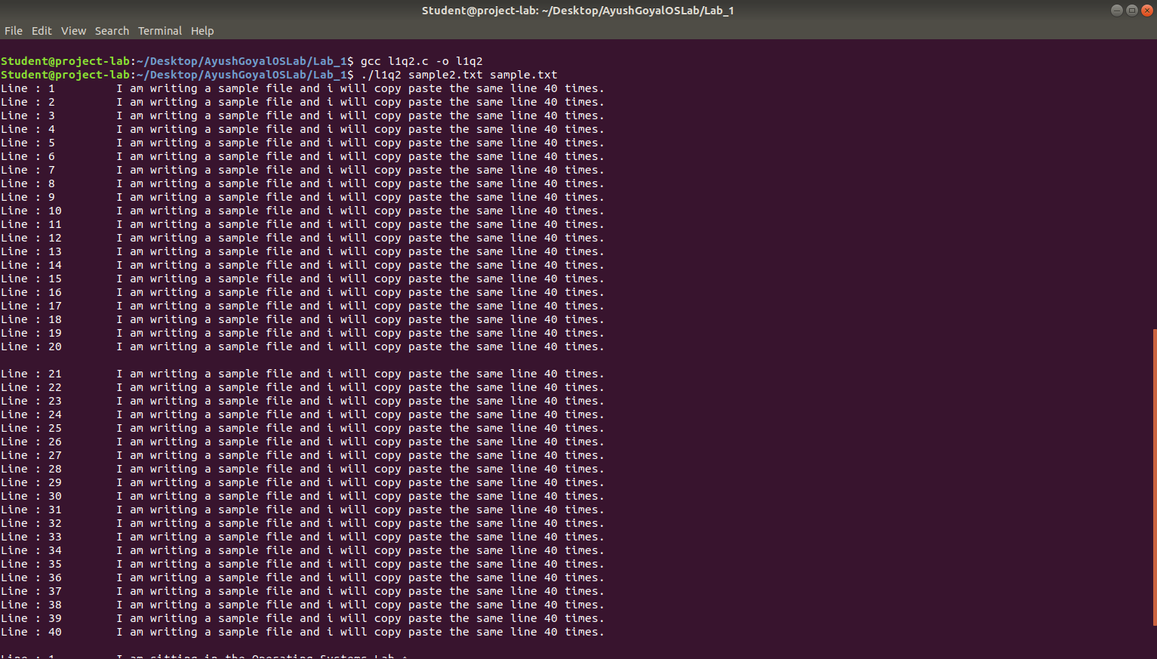

3. Demonstrate the use of different conversion specifiers and resulting output to allow the items to be printed.

Code:

#include<stdio.h>
#include<stdlib.h>
#include<errno.h>

//extern int errno

int main(){
int a = 18;
float b = 9.69;
char c = 'F';
char str[] = "Ayush Goyal";
printf("a = %d, b = %f, c = %c, str = %s, Hexadecimal for a = %x\n",a,b,c,str,a);
errno = EPERM;
printf("Error Access Number : %m\n");
}

Output:

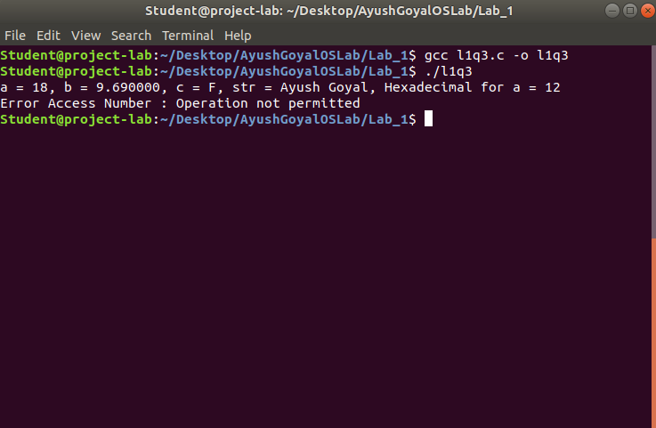

4. Write a program to copy character-by character copy is accomplished using calls to the functions referenced in stdio.h

Code:

#include<stdio.h>
#include <unistd.h>
#include<sys/stat.h>
#include<fcntl.h>
#include<stdlib.h>

int main(int argc, char *argv[]){
char c;
int in,out;
char buffer[128];
int nread;
if(argc!=3){
printf("\nInsufficient Arguments\n");
exit(1);
}
in=open(argv[1],O_RDWR);
out=open(argv[2],O_WRONLY|O_CREAT, S_IRUSR|S_IWUSR);
if( in==-1 || out==-1){
printf("File not found\n");
exit(1);
}
while(read(in,&c,1) == 1){
write(out,&c,1);
}
printf("Contents of file copied\n");
exit(0);
}

We have used the previously created file “sample.txt” and made an output file called “output.txt”.

Output:

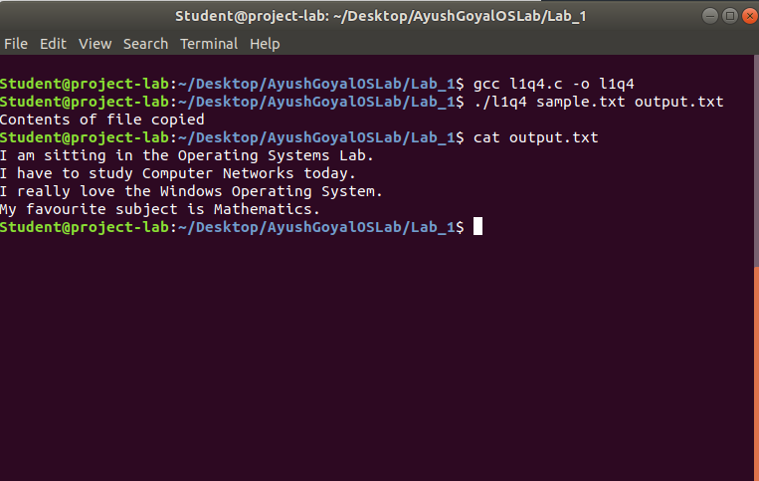

THE END

